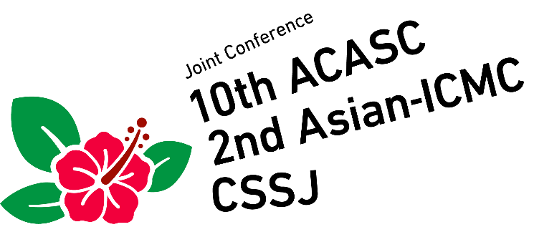

January 6-9, 2020, Okinawa, Japan

Application Form for Sponsorship & Advertisement

Please fill up the Application Form and send it to Secretariat of the 10th ACASC/2nd Asian-ICMC/CSSJ joint conference by fax or e-mail:

Fax.: +81-3-3818-4573
e-mail: acasc-icmc-cssj@mlsrv.csj.or.jp

Item No.: ( , , )
1. Conference Bag: 200,000 JPY, 2. Conference Lanyards: 200,000 JPY,
3. Promotional Pen: 150,000 JPY, 4. Promo. Note Book: 150,000 JPY,
5. Promo. Luggage Tags: 100,000 JPY, 6. Advertisement on Program Book: 70,000 JPY
Total amount: ( ) JPY *Tax included
Payment by Bank transfer
Bank information:
Bank name: MIZUHO BANK, LTD.
Branch name: HONGO
Branch address: 3-34-3 Hongo, Bunkyo-ku, Tokyo 113-0033, Japan
Swift code: MHCBJPJT
Beneficiary’s Account No. 075-2873771
Beneficiary name: Cryogenics and Superconductivity Society of Japan
Purpose of the remittance: Sponsor charge

Exhibitor Information:
Affiliation:
Contact Person:
Address:
Phone:
Fax:
E-mail:

Thank you very much for your cooperation.

